Neurodivergence Disclosure and Request for Workplace Accommodations

I am writing to share something important about how I work and think, and to request support that will help me—and potentially other neurodivergent colleagues—contribute our best work to SDI.
I have dyslexia and ADHD. Until now, I have worked hard to mask these aspects of how my brain functions, but I've come to realize that embracing my neurodivergent thinking style—rather than suppressing it—will allow me to bring significantly more value to our team.
I want to be clear: this is not a limitation. Research consistently shows that neurodivergent individuals like myself often possess exceptional strengths in creativity, problem-solving, pattern recognition, spatial reasoning, and innovative thinking.
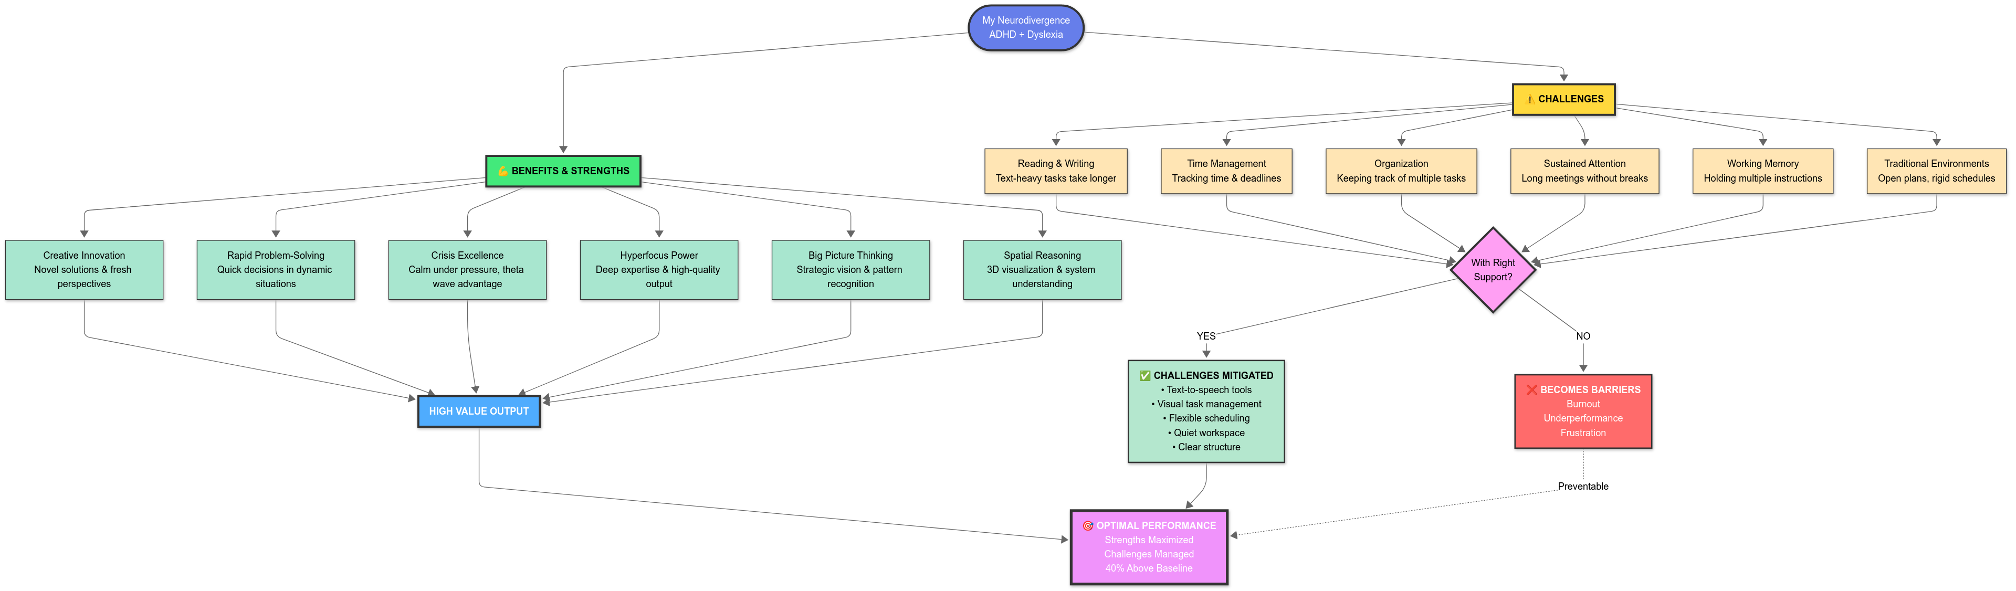
To fully access and utilise my strengths in the workplace, I need some specific accommodations and support. To perform at my highest level, I would benefit from the following accommodations:

Information Access and Communication
- Audio alternatives to written documentation: Access to text-to-speech software or the ability to receive important documents in audio format
- Verbal briefings: When possible, the option to receive project briefings and instructions verbally or through video rather than solely through written memos and the schedule regular check-in meetings in person or online.
- Recording permissions: The ability to record meetings or important discussions for later review
- Extra time for written tasks: Additional time for reading and responding to complex written materials, with no impact on my overall performance evaluation

Work Environment and Structure
- Flexible work arrangements: Options for remote work or flexible hours to align with my natural productivity rhythms.
- Quiet workspace: To minimize distractions and support focus. I was thinking perhaps we could rearrange things in the KYC Resource Centre, so that there is a designated quite zone for all staff who would like to work in quiet.
- Clear, structured project frameworks: Defined goals but to allow flexibility in how I achieve them.
- Visual project management tools: Access to software that allows me to organise and present my work spatially (mind-mapping tools, visual task boards).

Technology and Tools
- Assistive technology: Access to tools such as:
  - Text-to-speech and speech-to-text software
  - Mind-mapping and visual organization software
  - Grammar and spelling assistance tools
  - Task management apps designed for ADHD workflows

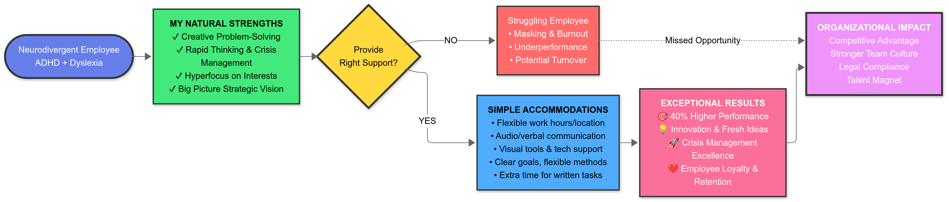

I want to emphasize that supporting neurodivergent staff is not just the right thing to do—it makes strong business sense:

Exceptional Strengths We Bring
- Creative Problem-Solving and Innovation
- Rapid Thinking and Crisis Management
- Spatial Reasoning and Big-Picture Thinking
- Pattern Recognition
- High Energy and Resilience
- Communication and Storytelling

Studies demonstrate that when neurodivergent employees are placed in roles aligned with their strengths and provided appropriate support, they can perform up to 40% above neurotypical colleagues in those specific areas. Companies like Microsoft, Google, Bloomberg, and Virgin actively recruit neurodivergent talent specifically because of these competitive advantages.
While I'm making this request for myself, I want to emphasise that implementing these supports will benefit other current colleagues who may be silently struggling, as well as future hires. Many neurodivergent individuals go undiagnosed or choose not to disclose due to stigma. By proactively creating an inclusive environment, we:
- Enable colleagues to work authentically without exhausting themselves through masking
- Attract exceptional talent who specifically seek neuroinclusive employers
- Prevent burnout and turnover among our current neurodivergent staff
- Model inclusive leadership that resonates across all diversity dimensions
Research indicates that 10-20% of the workforce is neurodivergent. That means we likely already have several colleagues who would benefit from these changes, whether they've disclosed or not.
I'm happy to discuss any of these requests in detail and work collaboratively to find solutions that work for both me and the organization. I'm also willing to be a resource if you'd like to develop broader neurodiversity inclusion initiatives.
I'm confident that with these supports in place, I can contribute at an even higher level and help our organization benefit from the proven advantages that neurodivergent thinking brings.
Thank you for taking the time to consider this request. I link useful resources and research pieces below, I look forward to discussing how we can move forward together.

Sincerely,
James

Resources and Research

https://77f20764.flowpaper.com/CityandGuildsNeurodiversityIndexReport2025/#page=16

https://employmenthero.com/blog/how-to-support-neurodiverse-people-in-the-workplace/

https://neurodiversitycentre.co.za/

https://add.org/benefits-of-adhd-employees/

